[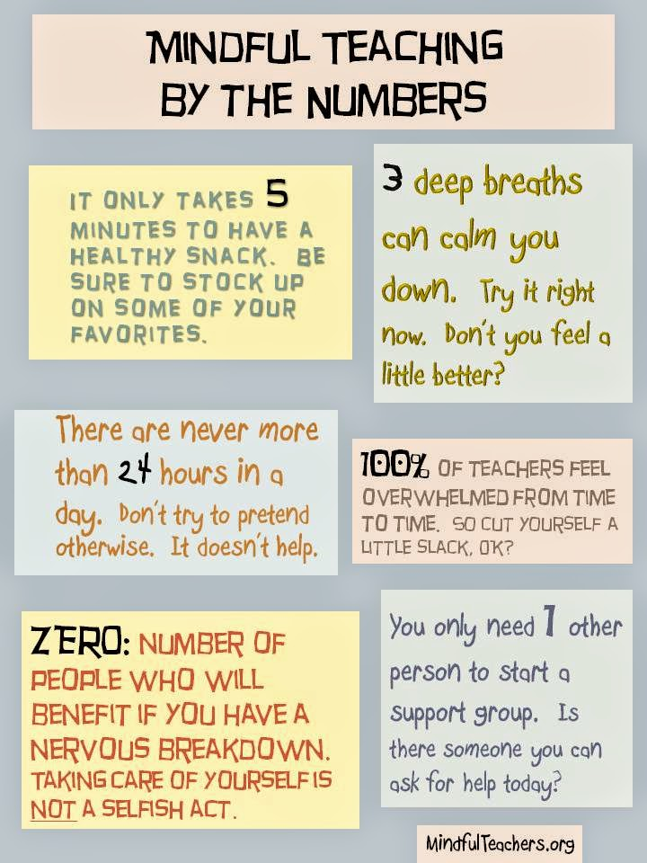](http://4.bp.blogspot.com/-6lA2a1WaS2A/Uz8f82N4MiI/AAAAAAAAAsA/sO0Uiph62Q4/s1600/mindful+teaching+by+the+numbers.jpg)